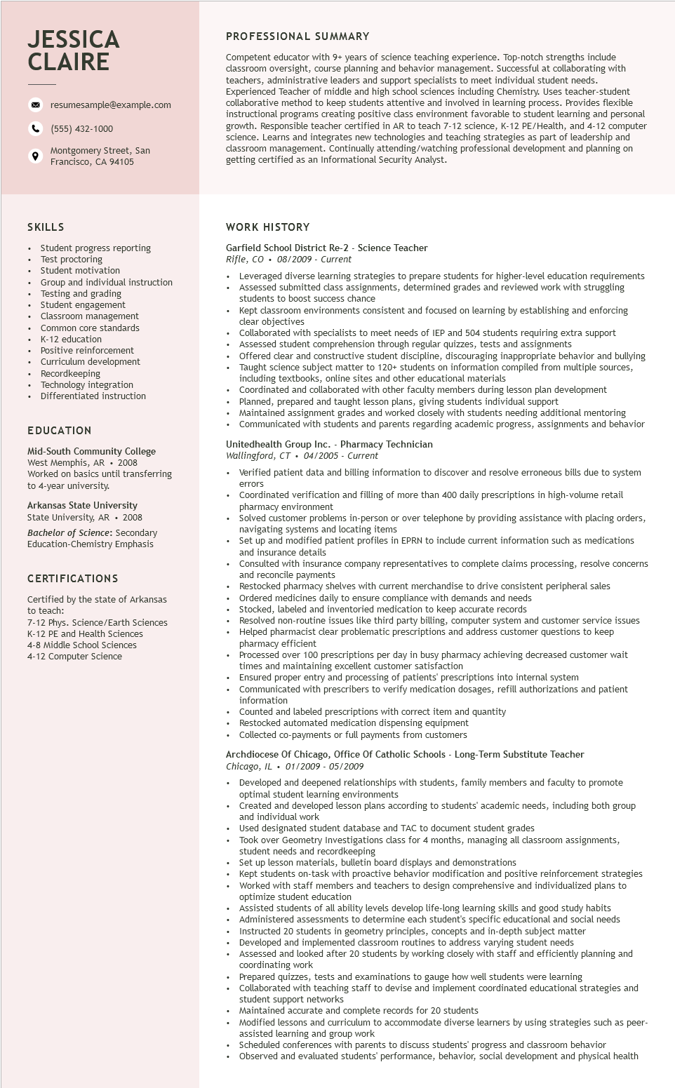
JESSICA CLAIRE
9
resumesample@example.com
(555) 432-1000
Montgomery Street, San
Francisco, CA 94105
PROFESSIONAL SUMMARY
Competent educator with 9+ years of science teaching experience. Top-notch strengths include classroom oversight, course planning and behavior management. Successful at collaborating with teachers, administrative leaders and support specialists to meet individual student needs. Experienced Teacher of middle and high school sciences including Chemistry. Uses teacher-student collaborative method to keep students attentive and involved in learning process. Provides flexible instructional I programs creating positive class environment favorable to student learning and personal growth. Responsible teacher certified in AR to teach 7-12 science, K-12 PE/Health, and 4-12 computer science. Learns and integrates new technologies and teaching strategies as part of leadership and classroom management. Continually attending/watching professional development and planning on getting certified as an Informational Security Analyst.
SKILLS
Student progress reporting
Test proctoring
Student motivation
Group and individual instruction
Testing and grading
Student engagement
Classroom management
Common core standards
K-12 education
Positive reinforcement Curriculum development Recordkeeping
• Technology integration Differentiated instruction
EDUCATION
Mid-South Community College
West Memphis, AR. 2008
Worked on basics until transferring
to 4-year university.
Arkansas State University
State University, AR. 2008
Bachelor of Science: Secondary Education-Chemistry Emphasis
CERTIFICATIONS
Certified by the state of Arkansas to teach:
7-12 Phys. Science/Earth Sciences K-12 PE and Health Sciences 4-8 Middle School Sciences
4-12 Computer Science
WORK HISTORY
Garfield School District Re-2 - Science Teacher
Rifle, CO 08/2009 - Current
• Leveraged diverse learning strategies to prepare students for higher-level education requirements Assessed submitted class assignments, determined grades and reviewed work with struggling students to boost success chance
Kept classroom environments consistent and focused on learning by establishing and enforcing clear objectives
Collaborated with specialists to meet needs of IEP and 504 students requiring extra support Assessed student comprehension through regular quizzes, tests and assignments
Offered clear and constructive student discipline, discouraging inappropriate behavior and bullying Taught science subject matter to 120+ students on information compiled from multiple sources, including textbooks, online sites and other educational materials
Coordinated and collaborated with other faculty members during lesson plan development Planned, prepared and taught lesson plans, giving students individual support
Maintained assignment grades and worked closely with students needing additional mentoring Communicated with students and parents regarding academic progress, assignments and behavior
Unitedhealth Group Inc. - Pharmacy Technician
Wallingford, CT 04/2005 Current
•
Verified patient data and billing information to discover and resolve erroneous bills due to system
errors
Coordinated verification and filling of more than 400 daily prescriptions in high-volume retail pharmacy environment
Solved customer problems in-person or over telephone by providing assistance with placing orders, navigating systems and locating items
Set up and modified patient profiles in EPRN to include current information such as medications and insurance details
Consulted with insurance company representatives to complete claims processing, resolve concerns and reconcile payment payments
Restock
Restocked pharmacy shelves with current merchandise to drive consistent peripheral sales Ordered medicines daily to ensure compliance with demands and needs
Stocked, labeled and inventoried medication to keep accurate records
Resolved non-routine issues like third party billing, computer system and customer service issues Helped pharmacist clear problematic prescriptions and address customer questions to keep pharmacy efficient
Processed over 100 prescriptions per day in busy pharmacy achieving decreased customer wait times and maintaining excellent customer satisfaction
Ensured proper entry and processing of patients' prescriptions into internal system
Communicated with prescribers to verify medication dosages, refill authorizations and patient information
Counted and labeled prescriptions with correct item and quantity
Restocked automated medication dispensing equipment
Collected co-payments or full payments from customers
Archdiocese Of Chicago, Office Of Catholic Schools - Long-Term Substitute Teacher Chicago, IL 01/2009 - 05/2009
• Developed and deepened relationships with students, family members and faculty to promote optimal student learning environments
Created and developed lesson plans according to students' academic needs, including both group and individual work
Used designated student database and TAC to document student grades
Took over Geometry Investigations class for 4 months, managing all classroom assignments, student needs and recordkeeping
Set up lesson mate Set up lesson materials, bulletin board displays and demonstrations
Kept students on-task with proactive behavior modification and positive reinforcement strategies Worked with staff members and teachers to design comprehensive and individualized plans to optimize student education
Assisted students of all ability levels develop life-long learning skills and good study habits Administered assessments to determine each student's specific educational and social needs Instructed 20 students in geometry principles, concepts and in-depth subject matter Developed and implemented classroom routines to address varying student needs
Assessed and I looked after 20 students by working closely with staff and efficiently planning and coordinating work
Prepared quizzes, tests and examinations to gauge how well students were learning
Collaborated with teaching staff to devise and implement coordinated educational strategies and student support networks
Maintained accurate and complete records for 20 students
Modified lessons and curriculum to accommodate diverse learners by using strategies such as peer- assisted learning and group work
Scheduled conferences with parents to discuss students' progress and classroom behavior
Observed and evaluated students' performance, behavior, social development and physical health

